EGADSS

Immunization Guidelines for version 1.0 BETA
DATE: Nov 1, 2004

Preamble:

After EGADSS second think tank and subsequent discussions both internally and with VCH and PHSA, it was decided that for the version 1.0 BETA the group would target clinical decision support around immunizations. Although more complicated than the prototype guidelines previously discussed, immunizations do not require accessing specific laboratory data and can, therefore, skip the “4 step” process described in the architecture. Instead, a “2 step” process can be used, which is much simpler to implement for the EMR. It is suggested that we will incorporate some laboratory data into the two step CDS during our testing to see how engine handles that data; however, that will not be necessary for this initial stage of development.

The guidelines developed for EGADSS 1.0 BETA will be based on the BC CDC Immunization Schedules published September 2004. Text for the rationale behind guidelines will be selected from appropriate sources, such as the Canadian Task Force on Preventive Health Care, the Canadian immunization guide (2002) and the BC CDC Immunization program Documentation (September 2004).

EXCLUSIONS: EGADSS guidelines for the 1.0 beta will not include any of the following high risk groups: post Stem Cell Transplant patients, multi-organ transplant patients, solid organ transplant patients, or immunizations of health and childcare workers.

Immunizations:

In EGADSS 1.0, the focus will be on the following immunizations recommended by the BC CDC:

Diphtheria
Pertussis
Tetanus
Polio
H. influenza B
Hepatitis B
Pneumococcal vaccine
Meningococcal C
Measles
Mumps
Rubella
Varicella

These guidelines will apply to both children and adults and will incorporate delays in the receiving immunizations.

To begin with, we will start with a single “mock up” guideline – “Tetanus booster due” and two simple patients as we prototype the system. From there we will use three immunizations schedules: MMR, Pneumococcal Conjugate in children, and Tetanus in adults (this will replace the overly simple “Tetanus booster due” example for prototyping. The accompanying patient profiles will test these guidelines during the alpha testing. Patients Mr Needs (who is overdue for his Tetanus) and Mrs Has (who has an up to date Tetanus status) will be used only with the mock guideline. The remaining patients will be useful for testing the three real guidelines in this document.

Prototype / Test Immunization Guideline: Tetanus Booster for Adults

This over simplified guideline will be used for testing purposes as the EGADSS 1.0 prototype is developed. It has the simplest of guidelines: if Td present within the last 10 years, do not recommend repeat. Otherwise recommend Td booster.

Contraindications: There are no contraindications to this guideline.

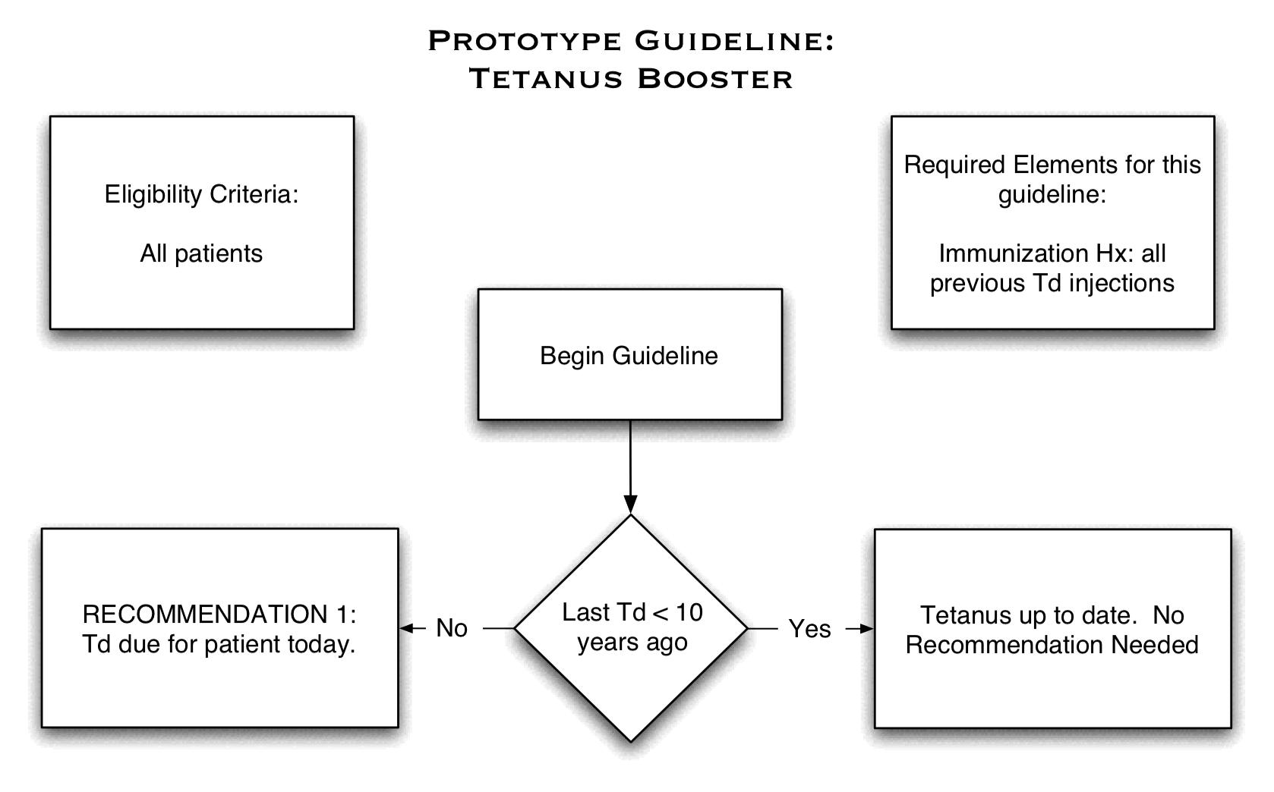

Measles Mumps and Rubella (MMR) (BCCDC Code: MMR)

In the Canadian general population, these vaccinations are given as one combined set (MMR) and not as individual injections. Two injections are recommended in the following schedule:

Recommended Schedule: First Dose >= 12 months, Second Dose >= 18 months and at least 1 month after first dose. If over 19 a second dose is not required unless the patient is a post-secondary student or health or childcare worker. NOTE: if second dose is given less than 1 month after the first dose, it is considered to be insufficient and that dose should be repeated.

Contraindications: Reaction to MMR, defer is severe acute illness, pregnancy, immunosuppression (significant HIV, organ transplant, prednisone), reaction to gelatin or neomycin.

One way to represent this guideline is the following:

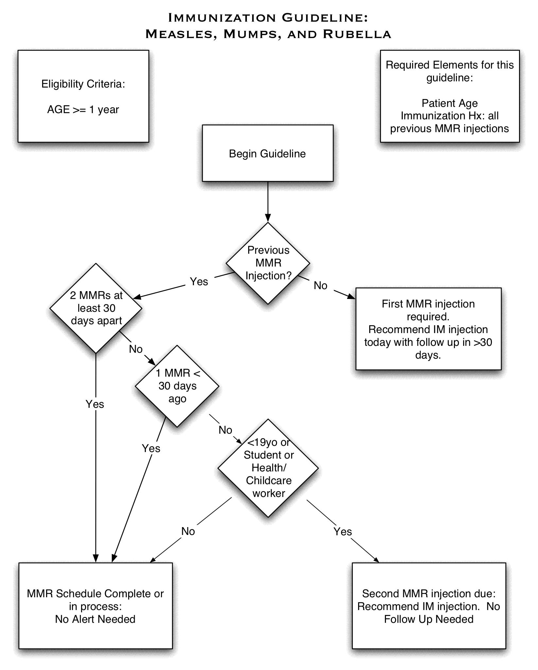

Pneumococcal Conjugate Vaccination Schedule
(BCCDC Code: PNEU-C-7)

This has come from the BC-CDC Sept 2004 Immunization Program Schedule. Pneumococcal Conjugate is a newly recommended vaccine in BC and it is available to infants born after July 1, 2003.

Recommended Schedule: Four doses at ages: 2 months, 4 months, 6 months, and 18 months. If started after one year of age, the schedule changes as less injections are needed to achieve the same immune response (the immune system is more reactive after one year).

Age 12-23 months: two injections at least eight weeks apart

Age 24-59 months: Healthy children: one dose. At High Risk of contracting pneumococcal disease: two doses 8 weeks apart.

Contraindications: Anaphylactic Reaction to pneumococcal conjugate vaccine.

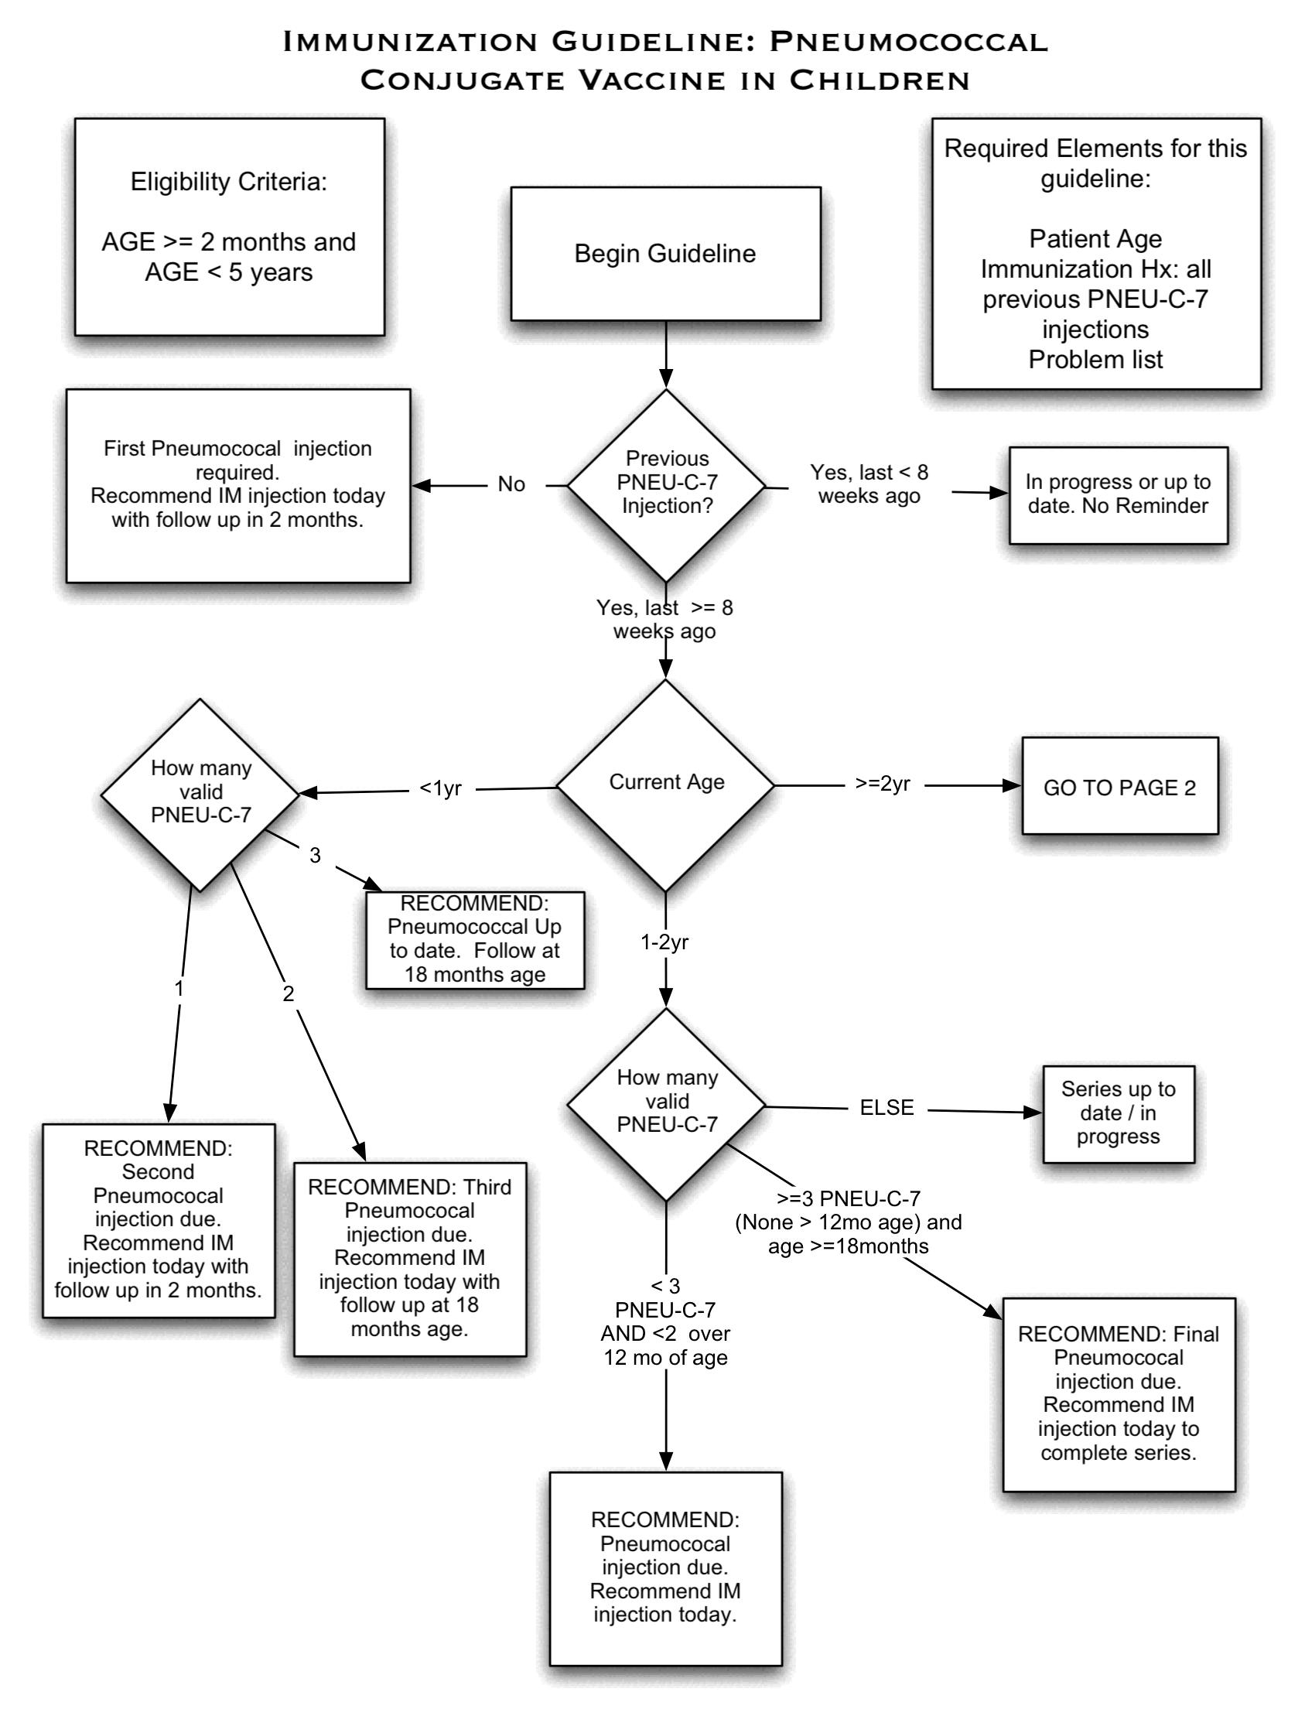
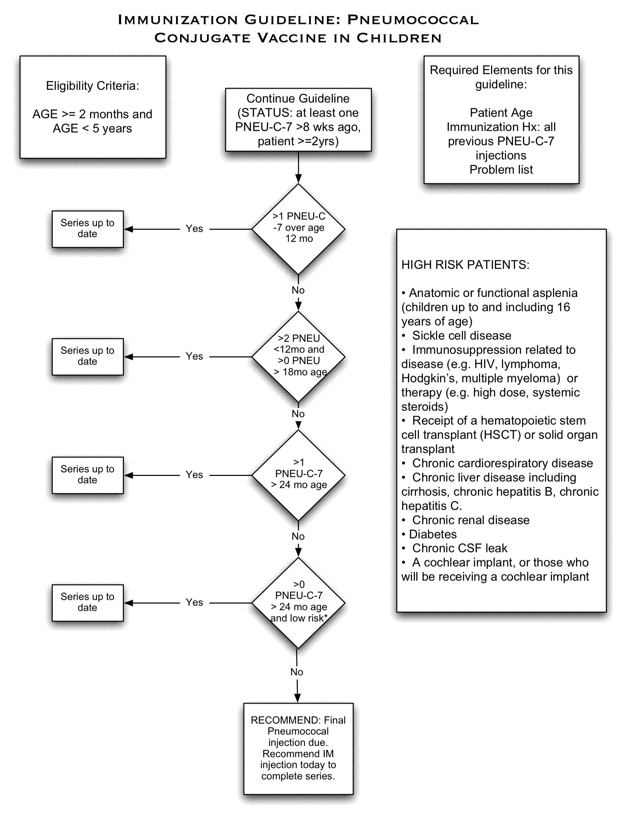

Tetanus Vaccination Schedule in Adults (Td)

This has come from the BC-CDC Sept 2004 Immunization Program Schedule.

Recommended Schedule: Primary series 0,2,6 months (0 = start of series) or in childhood. Confirmation of primary series is at least 3 Td spaced >=4 weeks apart. Once primary series is complete, booster is recommended every 10 years (or sooner if there is a dirty penetrating wound – this is not covered in this EGADSS guideline). Childhood immunizations are more complex and supercede the listing above.

Td is found in several vaccination combinations. Each of these will need to be checked for in the Arden guideline.

This guideline does not include wound management with Td and TIG.

Contraindications: Previous reaction to Tetanus vaccination. 1st trimester Pregnancy (OK to give after week 12)

